**Project Proposal**

Motion and Audio Controlled Smart Lights

**Project Summary:**

The issue of searching in the dark for a light a switch or reaching for your phone to use the torch will no longer be a problem. This is a solution that removes the need for a physical light switch or for grabbing your phone to light up a dark room in your house until you find the lights. Smart lights will function through the simple sound of a clap to turn on or off and during specified time periods and learnt behaviours, a motion sensor will trigger the lights on at specific times of day.

**Background:**

Trying to navigate around a living space in complete darkness is very difficult, especially if it is an unfamiliar space. Even more difficult, is fumbling for a light switch in a room to be able to see what the surroundings. Majority of people will go to the bathroom prior to going to bed and some will wake up in the middle of the night. In a sleep encumbered state trying to navigate in the darkness is even harder. As a result this solution will mitigate the need to search for any kind of light switch in the dark.

**Research Questions:**

How will the Arduino identify between claps and loud sounds?

How will the Arduino know when to use the motion sensor for the lights?

How can the Arduino learn what time periods to stay active and machine-learn?

**Aims:**

A basic motion sensor logging project will be set-up and left to run in a room for 24 hours that is used by 4 people. This data will be used to determine the most active hours of the day to use as a pre-set for the final solution. Once this has been run and determined it will be graphed to create a visualisation that shows activity periods so trends can be observed. The data that will be recorded will consist of a time-stamp, date and activity/inactivity status.

**Approaches:**

To approach this project, the following equipment will be required:

* Arduino
* Motion Sensor
* Microphone
* LED Light
* Jumper Cables
* USB Cable A-B
* Laptop

The Arduino will be set up with a motion sensor and microphone to take in input from the user whether that be movement or a clapping sound to turn on the light. Several tests will be run on the microphone from various test distance ranging from 0.5m to 3m to determine the ideal resistance cut-off (the threshold for what the quietest sound will be). As the system is used it will determine the time spent in a room, using this to learn and improve the timings that it is active and the time for which it remains active (only when activated by the motion sensor).

**Gantt Chart:**

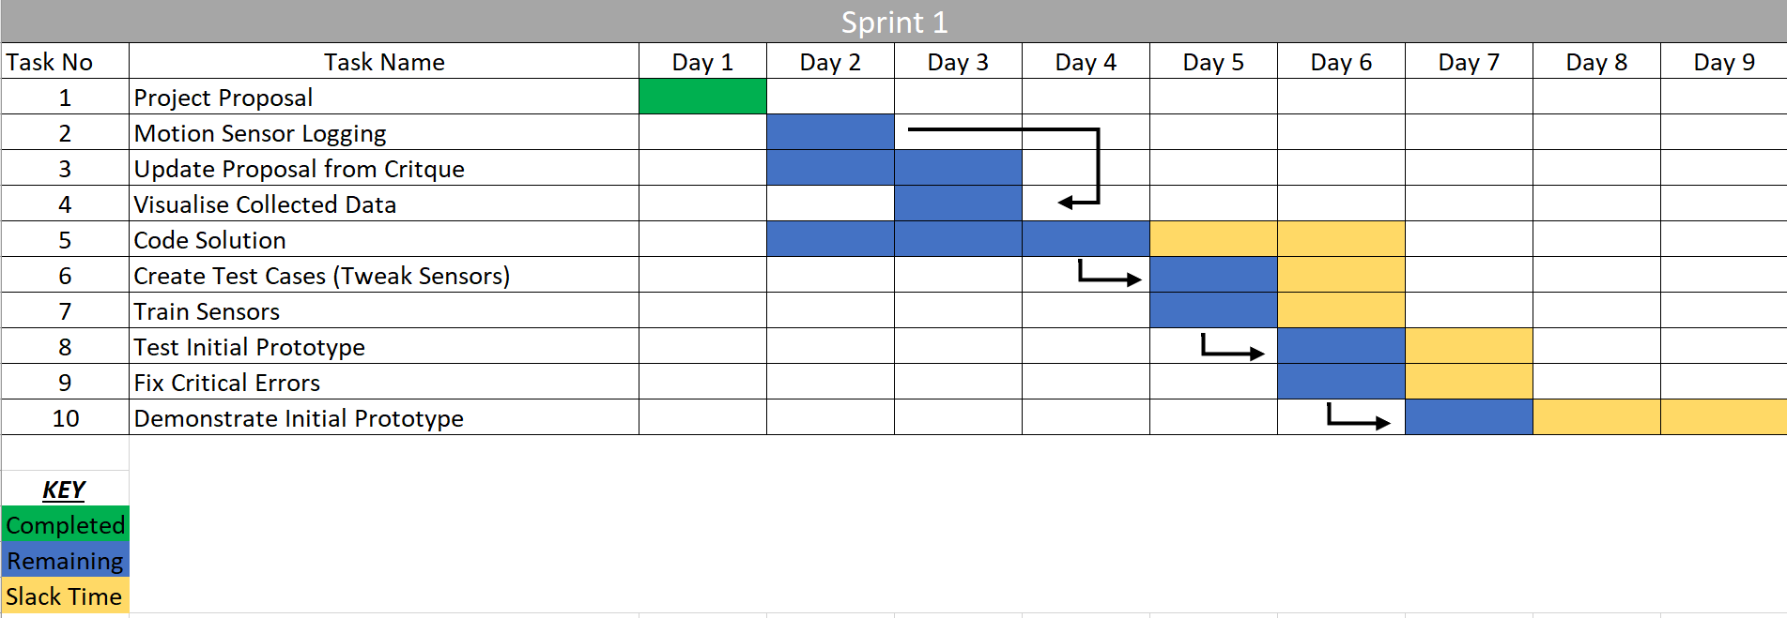

**Expected Output:**

It is expected that when someone walks into a room in the motion sensor ‘active’ time period the light will turn on and automatically turn off after a certain time period. When the user claps it is expected the light turns on, or turns off if it is already on. However, an issue can be foreseen with determining the difference between a loud noise and a clap, so the machine will have to be fine-tuned or taught what a clap sounds like.

**References:**

[1] Arduino. (2018). *Arduino - Language Reference*. Available: <https://www.arduino.cc/reference/en/>

[2] N. Bartnik. (2018). *Arduino Projects: Clap ON Clap OFF Light*. Available: <http://tutorial45.com/arduino-projects-clap-clap-off-light/>

[3] D. Magazine. (2018). *Three Stage Clap Switch*. Available: <https://diyodemag.com/projects/three_stage_clap_switch>